Task-0:
ssh bandit0.bandit@bandit.labs.overthewire.org -p 2220
using documentation stating:
- $ ssh <username>@<remote>
- If you want to specify a port, add -p 0000, (replace 0000 with the desired port number).
- You will be asked for your password once the connection is established. You will not see the cursor move or any characters input when you type your password.
- Logined with the password.
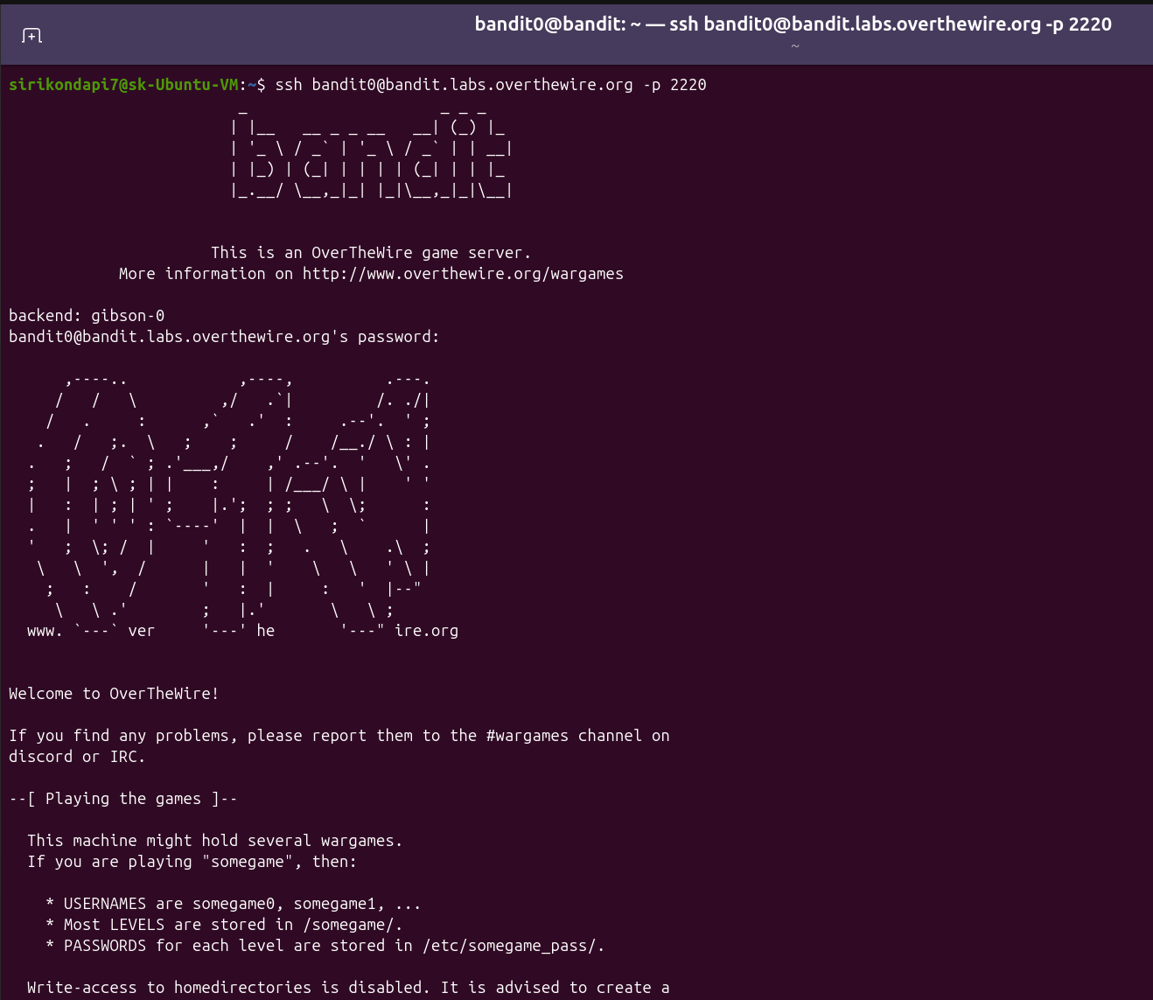

Task-1:
- Since I know the file name for the contents of file for password: cat readme
- Exit level 0 using exit command
- Logged onto level-1:
ssh bandit1.bandit@bandit.labs.overthewire.org -p 2220 and password

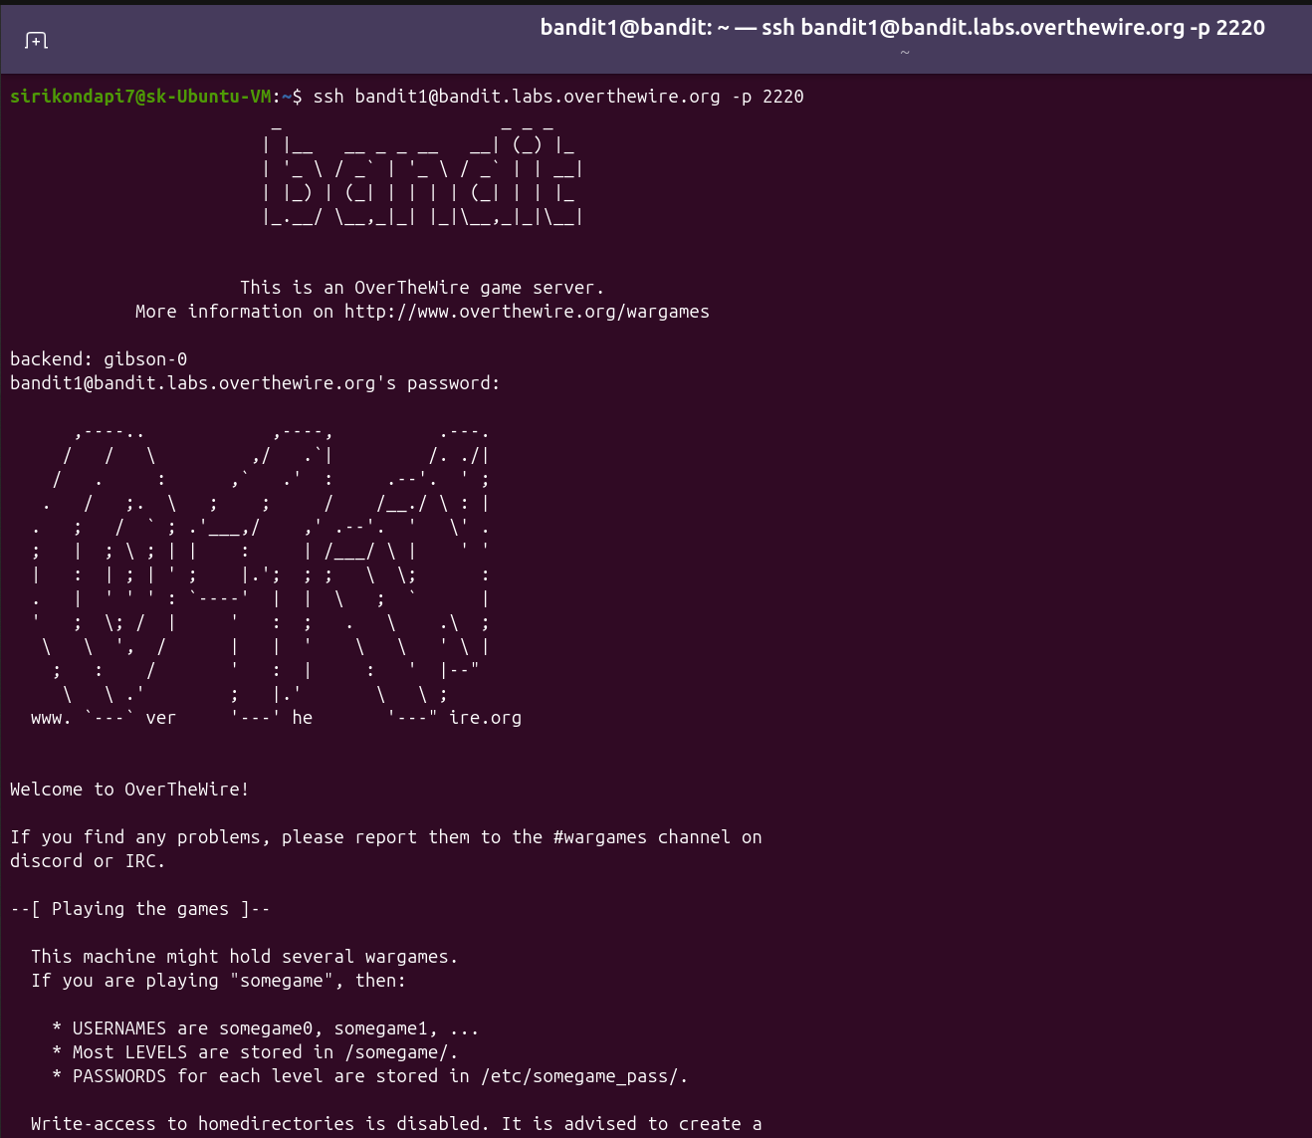
- Since file name is – and can’t be accessed directly using documentation:
- “Prefixing the filename with ./ tells the command to look for the file in the current directory. This prevents the command from seeing the dash as the first character of the argument.”
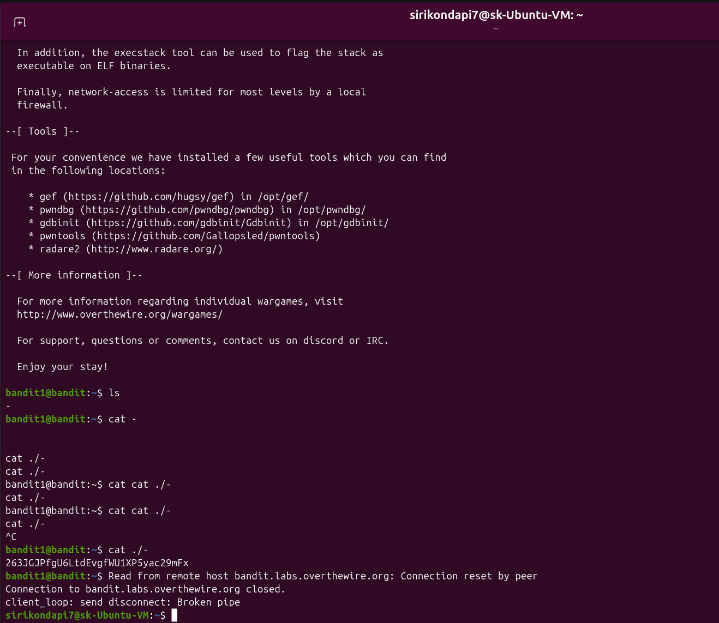

Task: 2-3
- Logged in with password.
- Since the name of the file consists of 4 different words separated by spaces we need to enclose the name in double quotes so that it is not interpreted as opening four different files.

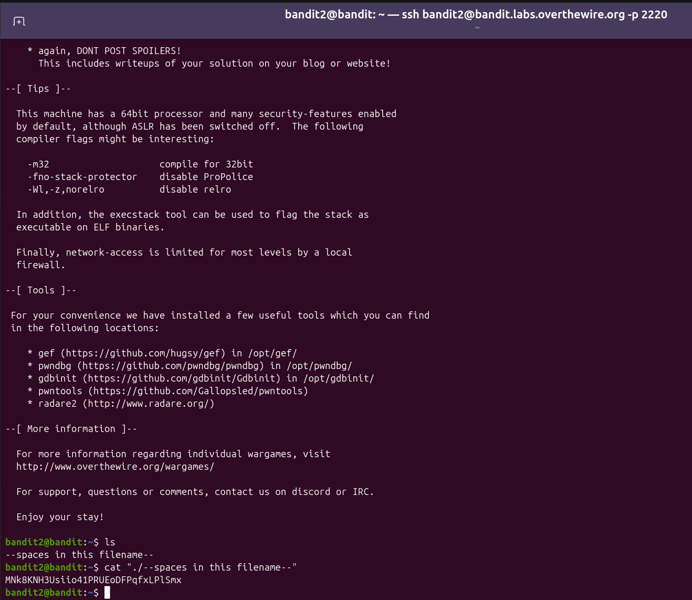

Level: 3-4
- Cd command is used to navigate to the directory
- Since hidden files are not shown by ls command we use ls -a
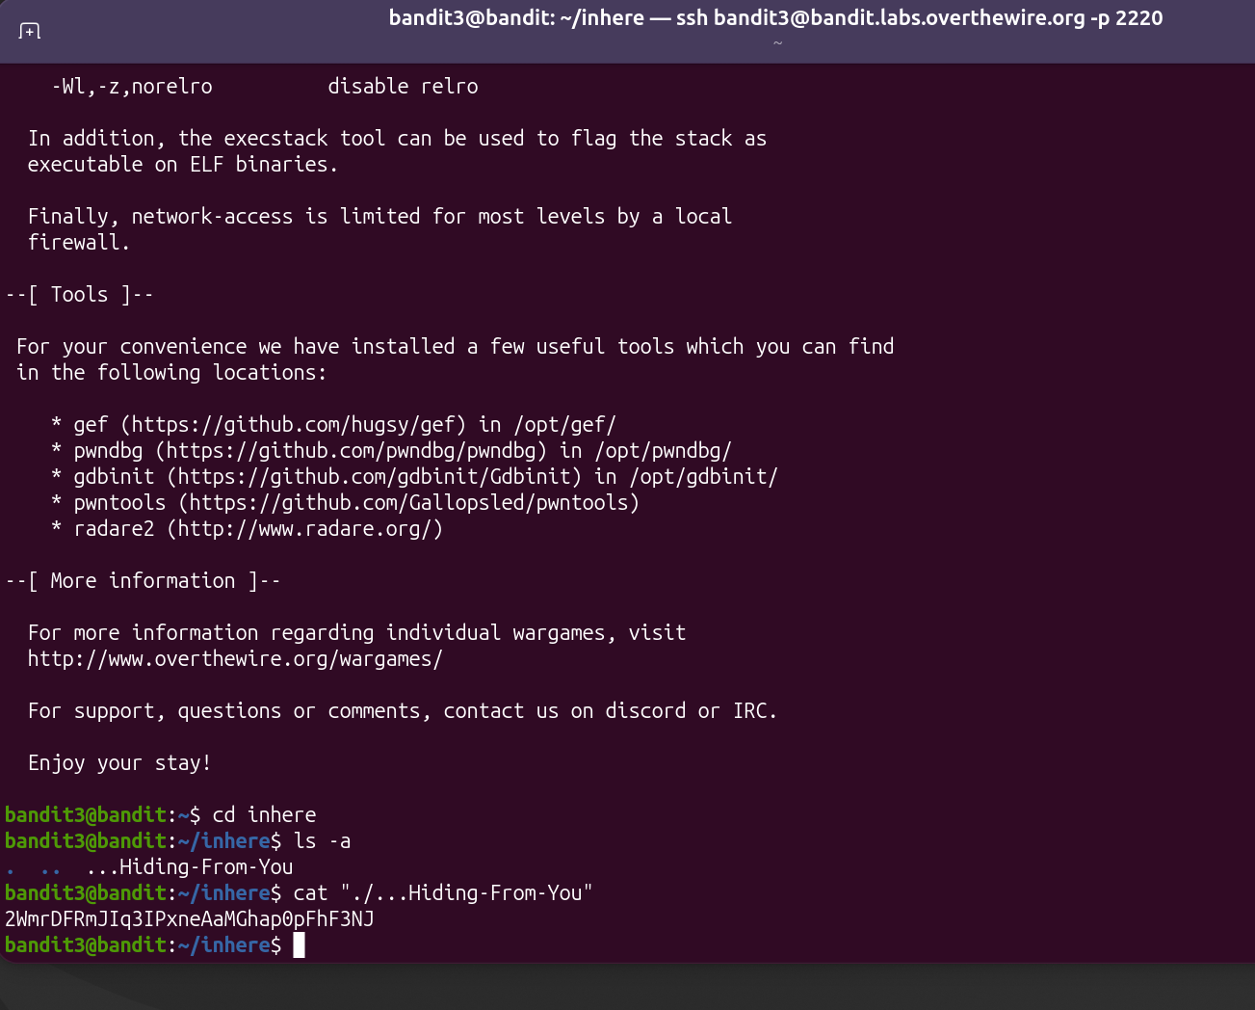

Level 4-5:

- From the internet :file * command scans every item in your current directory and outputs its detected file type.
- We use file ./* as file gives the file type of each file
- Since it’s a human readable file we look for an ascii file type

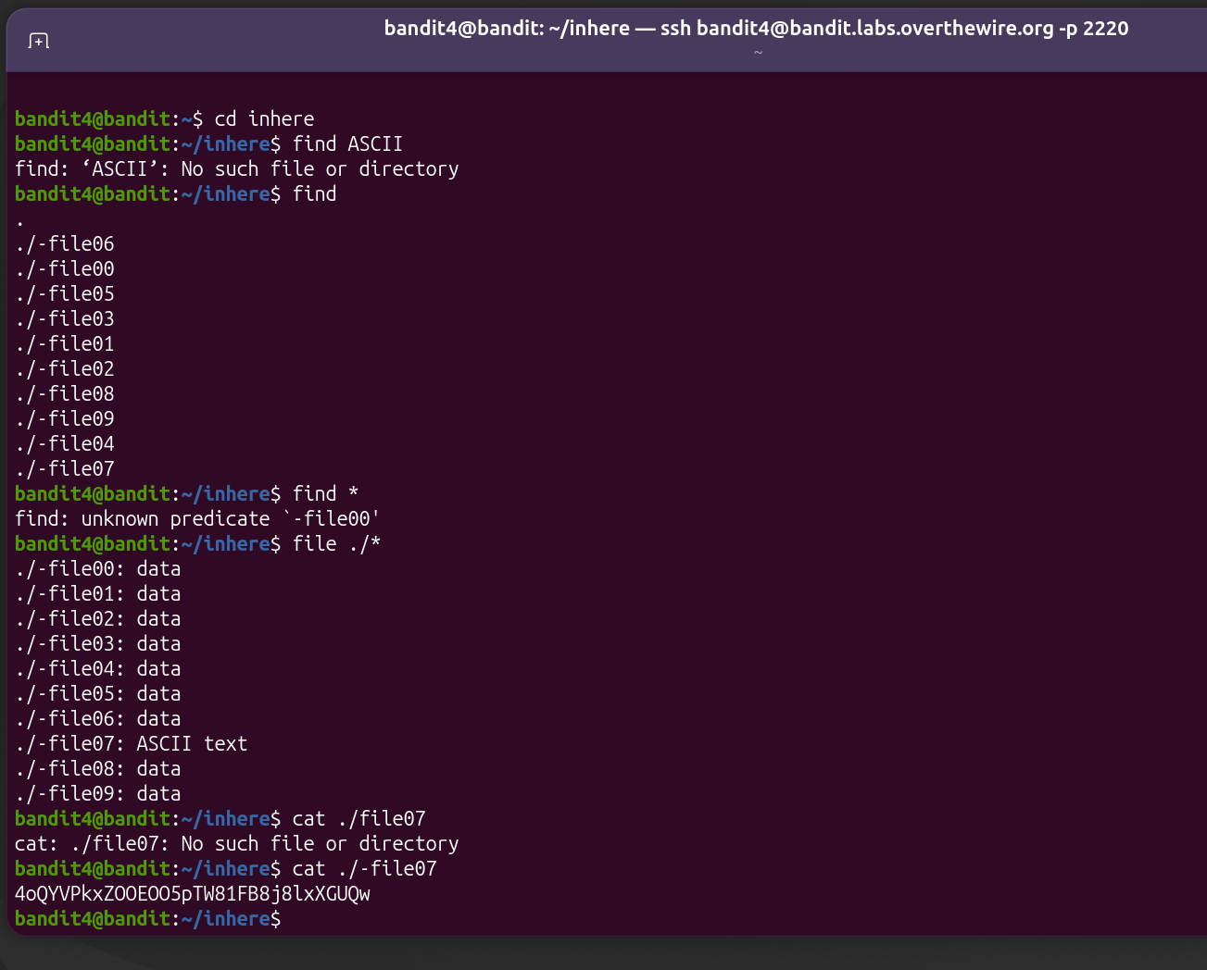

Level 5-6:
- From documentation
-size n[cwbkMG]
File uses less than, more than or exactly n units of space, rounding up. The following suffixes can be used:
`c' for bytes
- we use the command find -size 1033c
- since its to be human readable we check if file ty is acsii by file . /maybehere07/.file2
- for executability check Run the ls -l command followed by the filename:
- not showing x so not executable
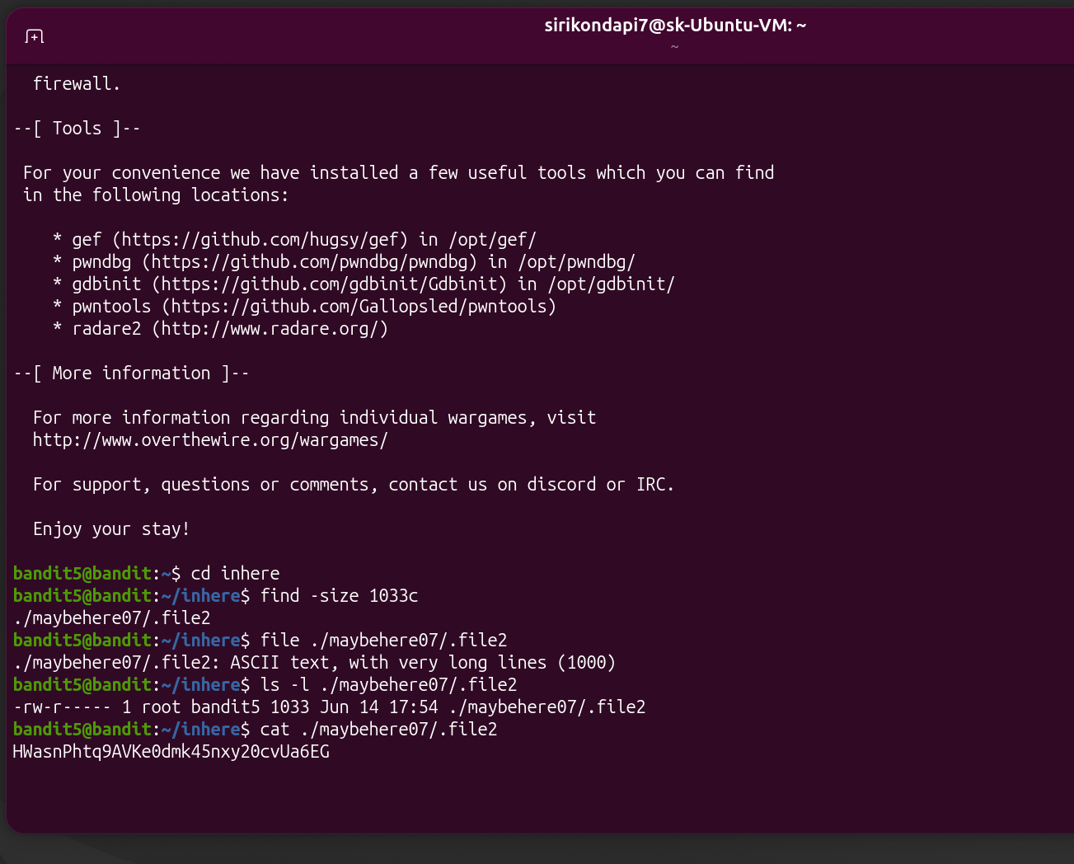

Level 6-7:
- Just running command find followed by the file specifications i.e.
find / -user bandit7 -group bandit6 -size 33c
results in errors.
- Going through all the files we only have 1 file for which we have permission to access
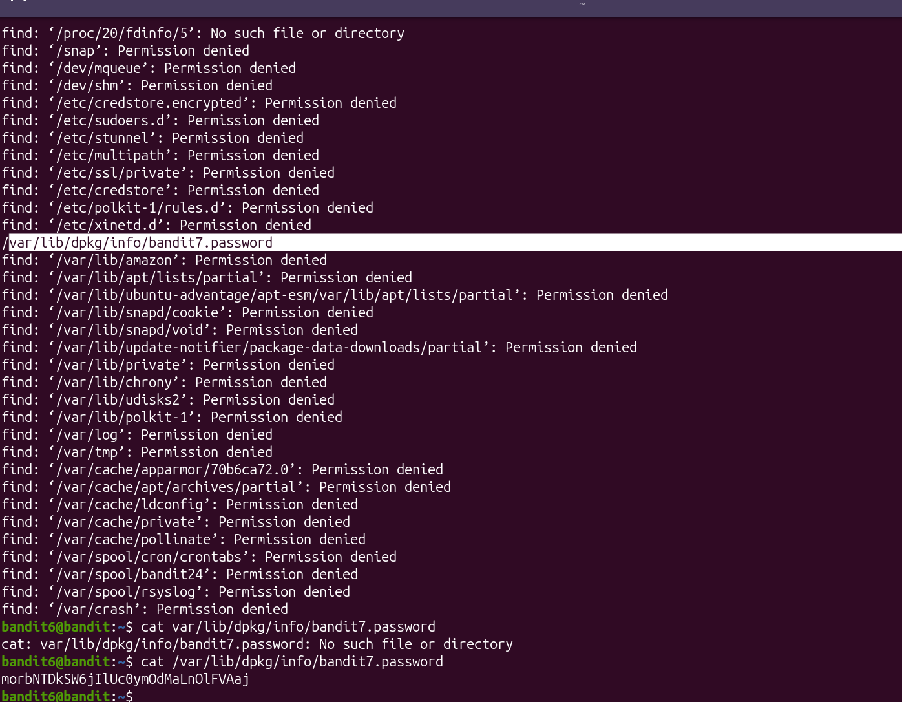

Level 7-8:
- Grep command is used to search inside a file.
- So we search for millionth inside file
grep millionth data.txt
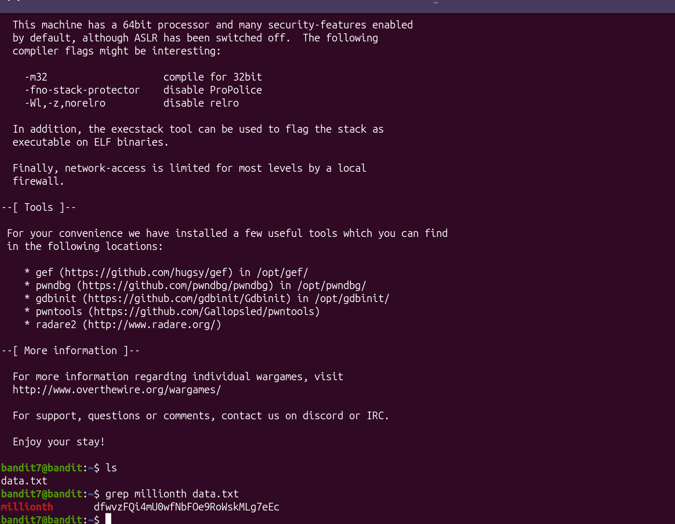

Level 8-9:
- Since we need to find a line that occurs only once:
From documentation:
uniq
-u, --unique
only print unique lines
- foe using uniq we need to sort and then send the sorted output into uniq command
sort data.txt | uniq -u
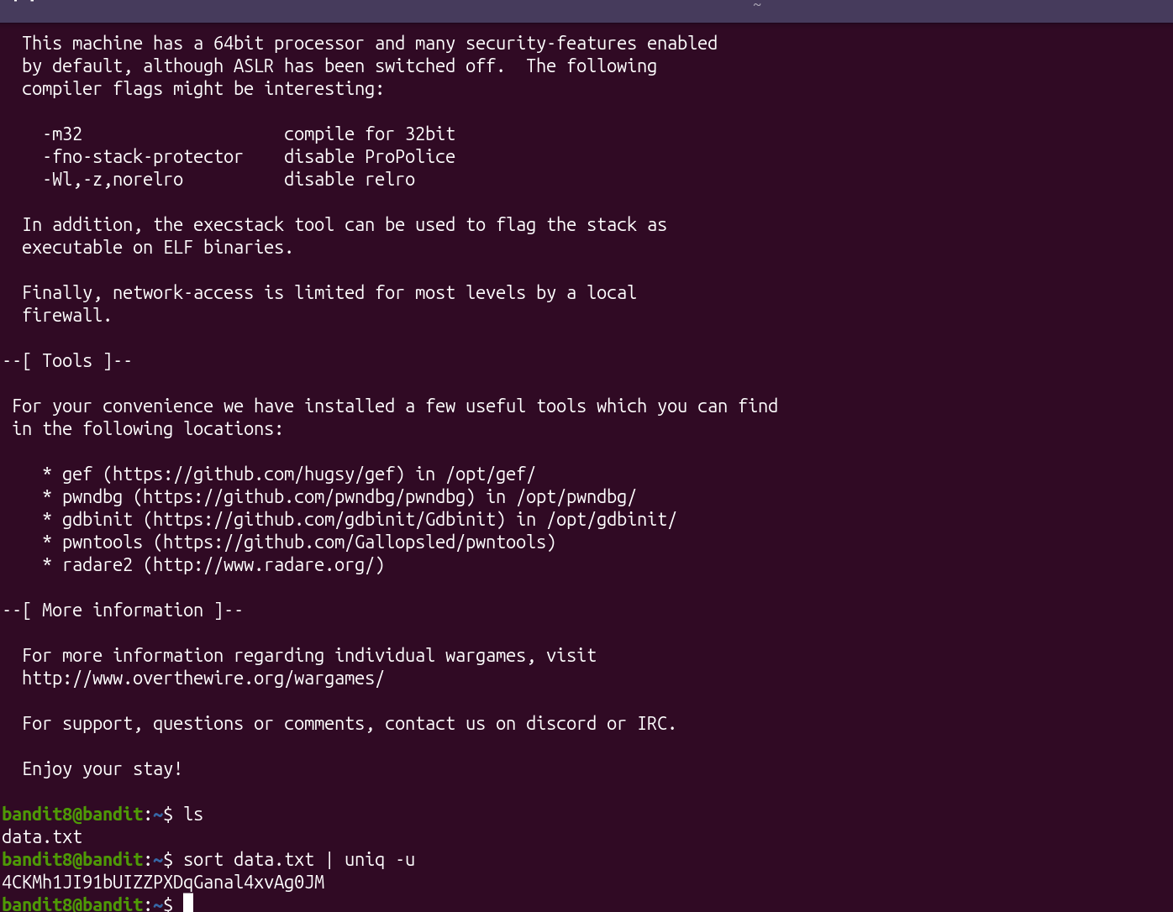

- Leve 9-10:
- We need to find out the human readable strings ie printable strings which is achieved by using strings command.
- But in these strings the password is preceded by multiple ‘=’.
- So we also add the grep command followed by ‘===’.
i.e strings data.txt | grep “===”
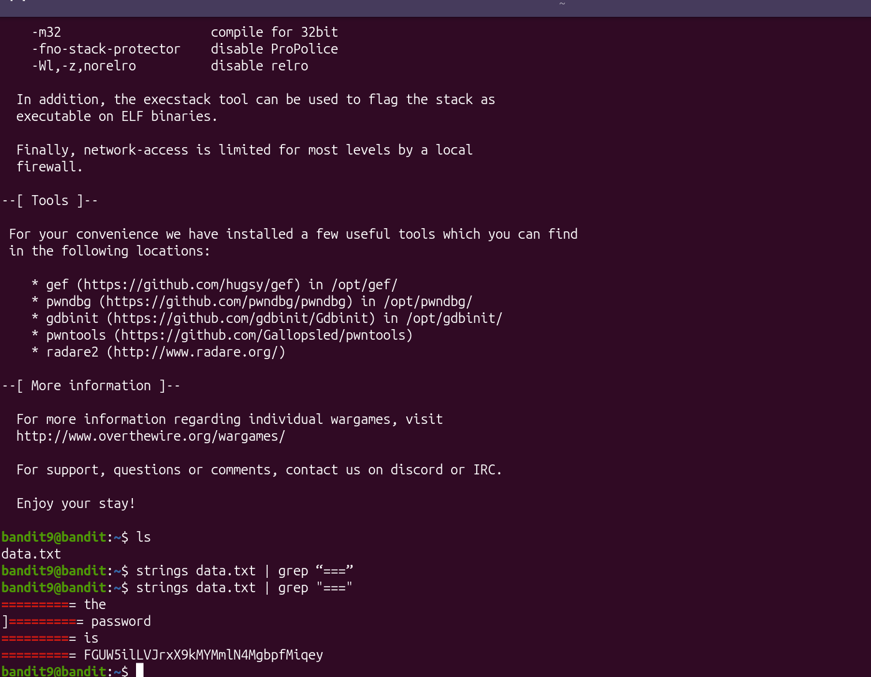

Level 10-11:
- Since the file is encoded with base64 we need to decode it with base64 so using documentation:
-d, --decode
decode data
- i.e. the command is base64 -d data.txt
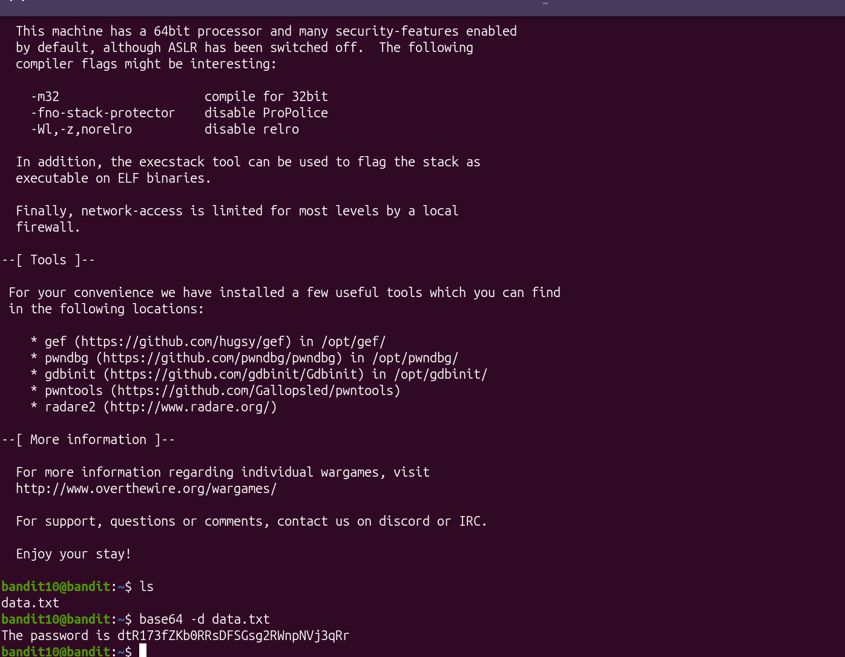

Level 11-12:
- All upper case and lowercase alphabets have been rotated by 13 positions
- Using documentation:
Implementation
tr
The ROT13 and ROT47 are fairly easy to implement using the Unix terminal application tr; to encrypt the string "Pack My Box With Five Dozen Liquor Jugs" in ROT13:
$ # Map upper case A-Z to N-ZA-M and lower case a-z to n-za-m
$ tr 'A-Za-z' 'N-ZA-Mn-za-m' <<< "Pack My Box With Five Dozen Liquor Jugs"
Cnpx Zl Obk Jvgu Svir Qbmra Yvdhbe Whtf
- The command is:
cat data.txt | tr 'A-Za-z' 'N-ZA-Mn-za-m'
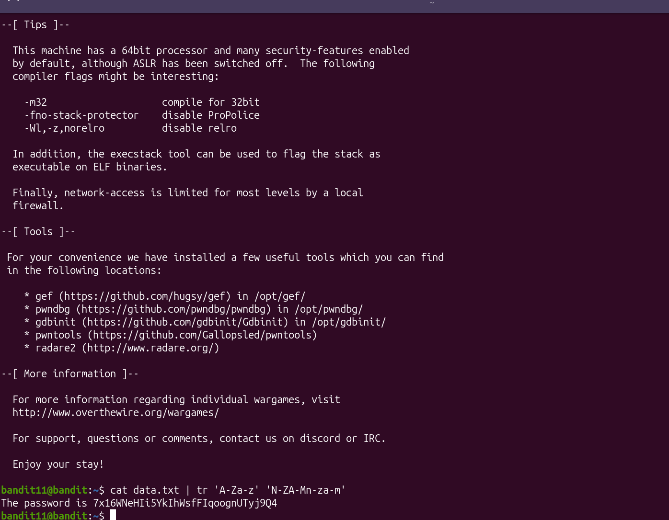

Level 12-13:
From manual:
- mktemp -d: Generates a uniquely named directory inside your default temporary folder (usually /tmp/).
- xxd -r : command reverses a hex dump back into binary data
- gzip -d bzip2 : are used to decompress compressed files back into their original, uncompressed forms. The -d flag explicitly stands for decompress
- tar -xf : extracts contents of archived files
Using all the commands as per the file requirement to decompress it.
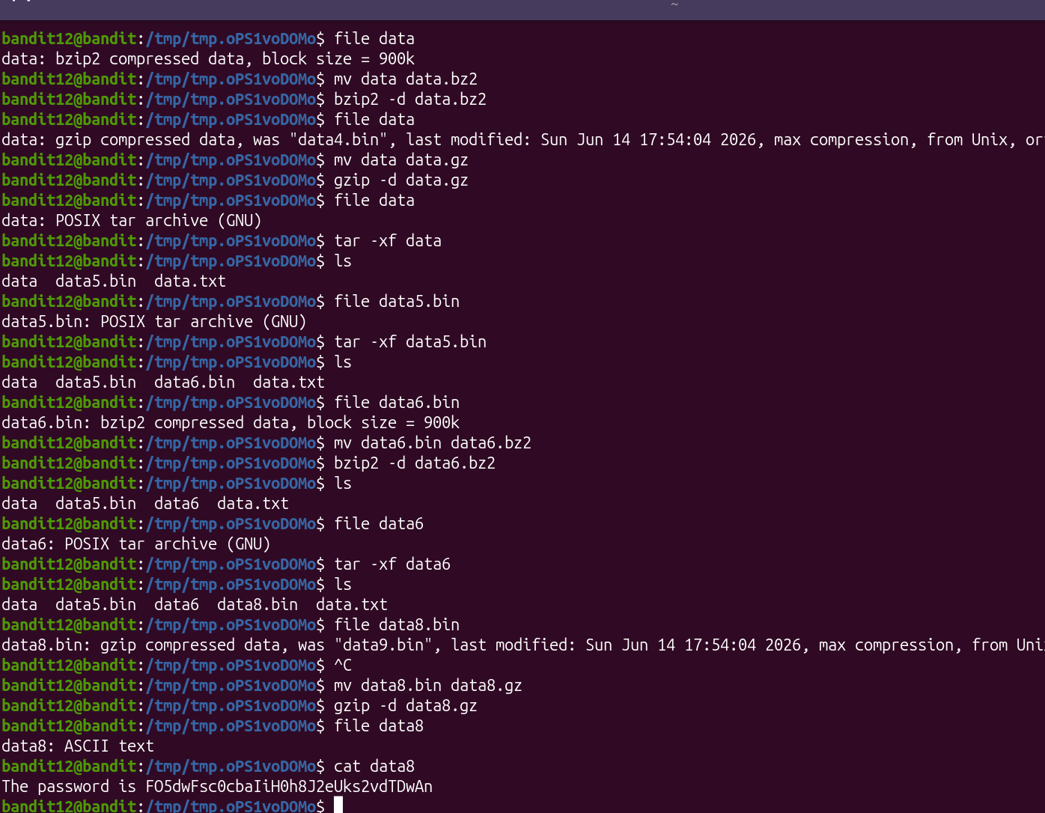

Level 13-14:
ls -la gives all hidden files revealing both hint and key file
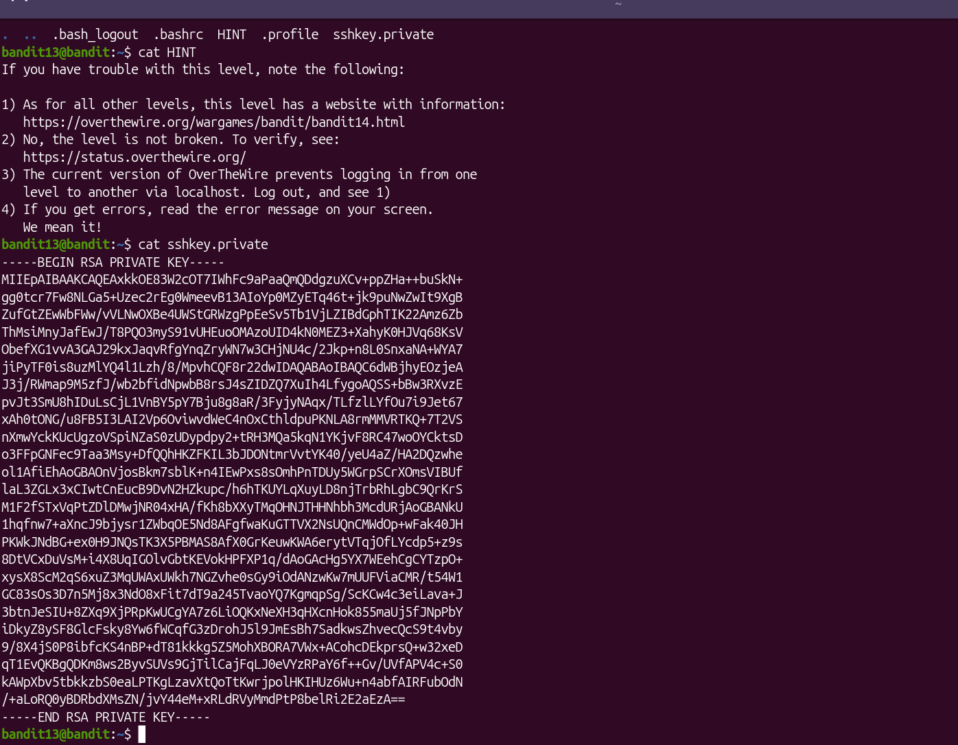

Logged onto 14:
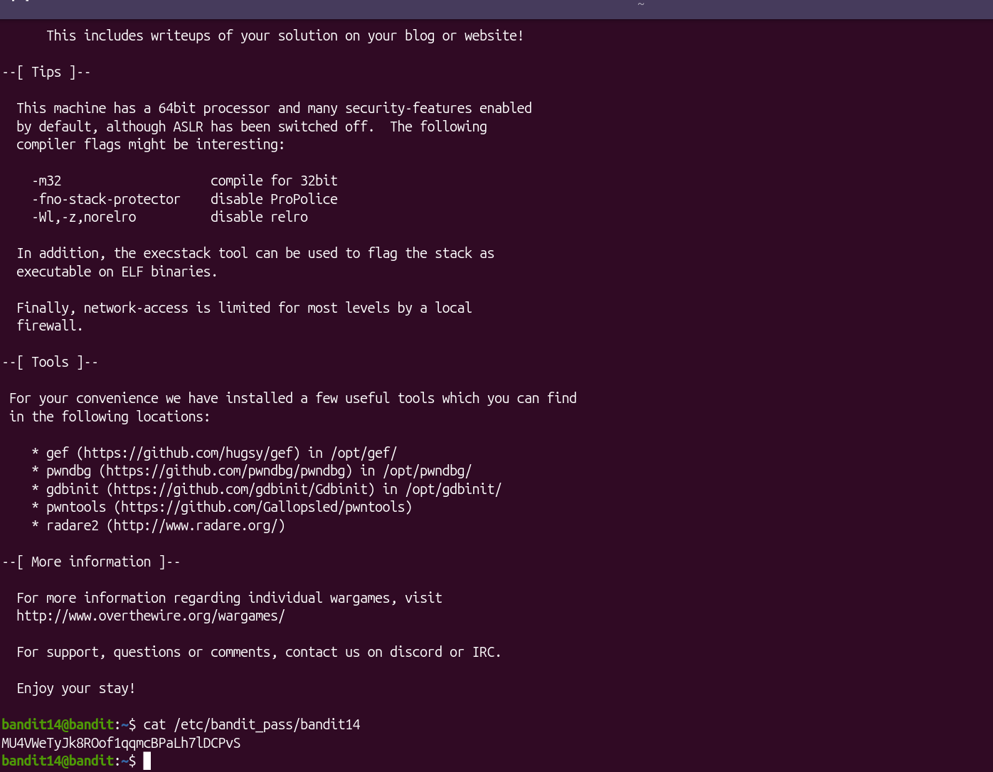
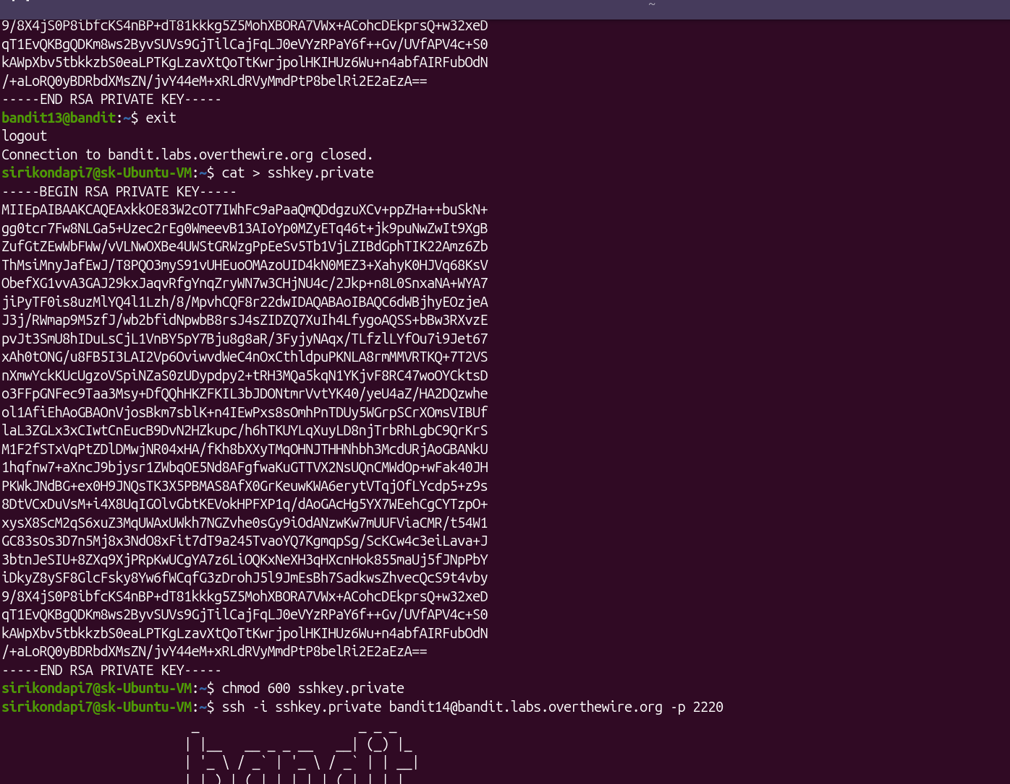

Level 14-15:
From documentation
- nc localhost: (short for netcat) is used to test network connections, read data, or write data across network connections targeting your own local machine.
- To work, it requires you to specify a port number at the end of the command. Without it, the command will fail.
i.e nc localhost 30000
